YEAR 12 CHEMISTRY NAME: ____________________________

ATOMIC STRUCTURE AND BONDING ASSIGNMENT TEST 1 (30 MARKS)

Part A: Multiple Choice (10 Marks)

Choose the best answer and write ALL your answers in the appropriate box below

1 | 2 | 3 | 4 | 5 | 6 | 7 | 8 | 9 | 10

1. Which one of the following electron configurations represents an element that would most likely form a monoatomic ion with a charge or valency of (–2)?

a) 2 2
b) 2 4
c) 2 6
d) 2 8

2. In which one of the following pairs do both chemical species have the same electron configuration?

a) Na⁺ and Ar
b) Na⁺ and F⁻
c) Na⁺ and K⁺
d) Na⁺ and Mg⁺³

3. What is the formula of an ionic compound consisting of positive ions with a configuration 2,8,8 and negative ions with the same configuration?

a) LiF
b) MgS
c) NaF
d) KCℓ

4. Which one of the following best explains the decrease in atomic radius as the atomic number increases across Period 3 of the Periodic Table?

a) increasing nuclear charge.
b) decreasing number of neutrons.
c) decreasing number of protons.
d) the elements becoming more noble gas-like.

5. The list of substances that contains ionic bonds only is:

a) potassium chloride, magnesium oxide, copper(II) chloride.
b) potassium chloride, magnesium nitrate, carbon dioxide.
c) magnesium oxide, copper(II) chloride, sulfur trioxide.
d) magnesium nitrate, potassium oxide, carbon dioxide.

6. The following graph shows the first to seventh ionisation energies of an element X
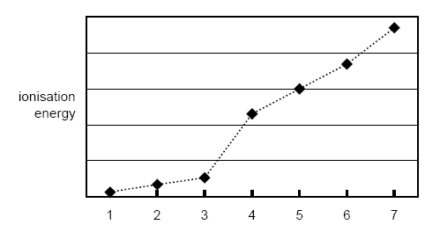
Which one of the following is X most likely to be?

a) boron
b) nitrogen
c) aluminium
d) silicon

7. When solid iodine is heated, it changes into a purple gas without passing through the liquid state. In this process

a) covalent bonds between iodine atoms are broken.
b) intermolecular forces between iodine molecules are broken.
c) ionic forces between iodine atoms are overcome.
d) metallic attraction between iodine molecules are overcome.

8 Two atoms X and Y have electronic configurations as shown below:

X : 2 8 2 Y : 2 8 7

The compound formed when X and Y combine is most likely to be

a) ionic, with formula X₂Y
b) ionic, with formula XY₂
c) covalent, with formula XY₄
d) covalent, with formula X₂Y₅

9. The table below gives information about three pure solids designated X, Y and Z.

 | X | Y | Z
Approximate melting point (ºC) | 800 | 3500 | 1500
Electrical conductivity in the solid state | Nil | Moderate | high
Electrical conductivity in the liquid (melted) state | High | Cannot be easily tested | high

Which of the following describes the bonding present in the three substances?

 | X | Y | Z
a) | Covalent molecular | Covalent network | Ionic
b) | Ionic | Covalent network | Metallic
c) | Ionic | Metallic | Metallic
d) | Covalent molecular | Metallic | Ionic
10. Which of the following descriptions about ionic and covalent bonds is FALSE:

a) ionic transfer electrons, covalent share them
b) ionic always involves metal/non metal atom combinations, covalent always involves non metal/non metal atom combinations
c) ionic is weaker than covalent
d) they both involve electrostatic attraction to hold them together

Part B: Short Answer (20 Marks)

Write ALL your answers in the space provided

1. Complete the following table: (4 marks)

Element | Symbol | Electron configuration | No. of valence electrons | Normal valency of ion | Noble gas with same electron configuration
Lithium | Li
Sulfur |  |  | 6

2. Classify the following as ionic or covalent network, covalent molecular or metallic substances: (4 marks)

N₂, SO₂, KF, ICl, Al₂O₃, NH₄Cl, SiC, liquid mercury

IONIC | COVALENT NETWORK | COVALENT MOLECULAR | METALLIC

3. Using the information in the table, identify the substances A, B, C and D from the following list:

Aluminium oxide Gold Copper
Candle wax Sodium chloride Silicon dioxide
Cobalt nitrate Sucrose (C₁₂H₂₂O₁₁) Sulfur (4 marks)

Substance | Electrical Conductivity |  |  | Solubility in water | Colour of solid | Name of substance
Substance | Solid | Liquid | Water  Solution | Solubility in water | Colour of solid | Name of substance
A | Nil | Conducts | Conducts | Soluble | White
B | Nil | Nil | Nil | Soluble | White
C | Conducts | Conducts | - | Insoluble | Pink
D | Nil | Conducts | - | Insoluble | White
4. Use the periodic table to write the chemical symbols for the following elements. (2 marks)

a) The element that forms a –2 ion with the electron configuration: 2 8 8 _____

b) An element from period three with the largest atomic radius _____

c) The most electronegative element in group 17 _____

d) An element from period two that is chemically most similar to the element with
atomic number 15 _____

5. Which of the graphs below best represents the trend in: (2 marks)

Graph 1 Graph 2 Graph 3 Graph 4

a) Atomic radii across a period graph _____

b) Valence electrons down a group graph _____

c) Electronegativity across a period graph _____

d) Melting points down Group 2 graph _____

6. A plot showing the successive ionisation energies of calcium is given below.

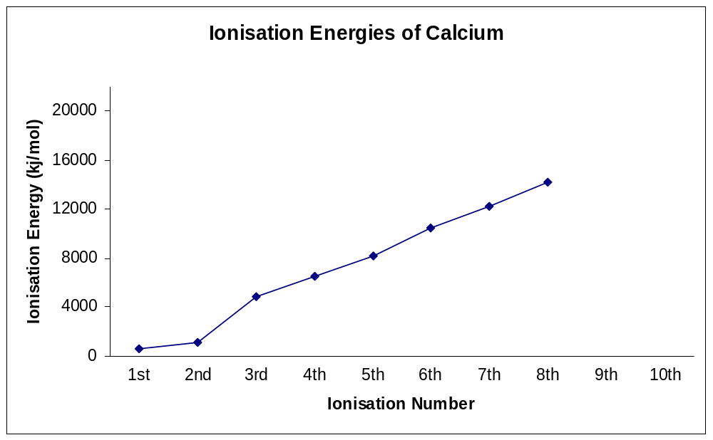

a. Explain the gentle increase between the first and second ionisation energies for calcium. [2 marks]

b. Explain the significant increase in moving from the second to the third ionisation energy for calcium. [2 marks]

END OF TEST

